Exercise 3 – SDN Control Plane

1.OpenFlow (25P)

a)(5P) What are the two main components of OpenFlow?

The Two main Components of OpenFlow are:

1.Flow Table: Reactively or proactively defines how incoming packets are forwarded.

2.Group Table: Additional method of forwarding packets.

b)(5P) Please explain the packet matching process of OpenFlow.

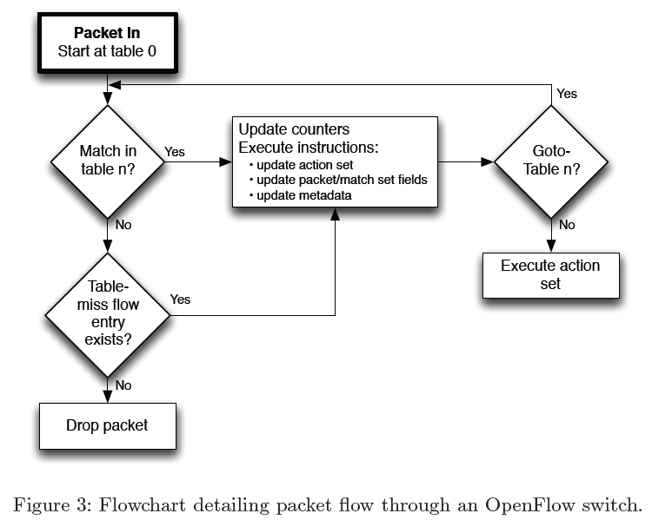

The switch starts by performing a table lookup in the first flow table, and based on pipeline processing, may perform table lookups in other flow tables.

Packet match fields are extracted from the packet. Packet match fields used for table lookups depend on the packet type, and typically include various packet header fields, such as Ethernet source address or IPv4 destination address. In addition to packet headers, matches can also be performed against the ingress port and metadata fields. Metadata may be used to pass information between tables in a switch. The packet match fields represent the packet in its current state, if actions applied in a previous table using the Apply-Actions changed the packet headers, those changes are reflected in the packet match fields.

A packet matches a ow table entry if the values in the packet match elds used for the lookup match

those defined in the flow table entry. If a flow table entry field has a value of ANY (eld omitted), it

matches all possible values in the header. If the switch supports arbitrary bitmasks on specific match fields, these masks can more precisely specify matches.

The packet is matched against the table and only the highest priority ow entry that matches the

packet must be selected. The counters associated with the selected flow entry must be updated and the instruction set included in the selected flow entry must be applied. If there are multiple matching flow entries with the same highest priority, the selected flow entry is explicitly undefined. This case can only arise when a controller writer never sets the OFPFF_CHECK_OVERLAP

bit on ow mod messages and adds overlapping entries.

IP fragments must be reassembled before pipeline processing if the switch configuration contains the OFPC_FRAG_REASM flag.

This version of the specification does not dene the expected behavior when a switch receives a mal-formed or corrupted packet

c)(5P) What is the task of the OpenFlow Channel?

The OpenFlow channel is the interface that connects each OpenFlow switch to a controller. Through this interface, the controller configures and manages the switch, receives events from the switch, and sends packets out the switch.

Between the datapath and the OpenFlow channel, the interface is implementation-specific, however all OpenFlow channel messages must be formatted according to the OpenFlow protocol. The OpenFlow channel is usually encrypted using TLS, but may be run directly over TCP

d)(10P) In the Figure below, the flow tables of a switch are illustrated

i.(5P) Please sketch the way a packet takes through the tables after arriving on

ingress port 45.

ii.(5P) Please explain what the options of handling a packet that arrives on ingress

port 1024 are, depending on the configuration of the switch.

2.FlowVisor (50P)

a.(10P) Please indicate the flows paces that FlowVisor will set up to realize these slices.

b.(25P) Based on the slices created in a, which of the following statements are true? Give reasons for your answer.

a.(5P) Controller c1 is allowed to install the following rule in switch s2: Forward all

incoming traffic on port 2 with TCP port 80 and source ip 10.0.0.3 (h3) via port 1

b.(5P) Controller c1 is allowed to install the following rule in switch s3: Forward all

incoming traffic on port 2 with TCP port 1234 via port 1.

c.(5P)If the link s1-s3 is down, video traffic with TCP port 1234 can no longer be forwarded from h1 to h4

d.(5P) FlowVisor will return an error to controller c2 if c2 tries to set up the rule

“forward all traffic with source-IP 10.0.04 (h4) via port 2” on switch s4.

e.(5P) It is impossible to create such a virtualized network with traditional

networking techniques.

C.(15P) FlowVisor has to process the so-called new flow messages,i.e., those messages that have to be forwarded to the controller in case of a table-miss at an OpenFlow switch.Here, FlowVisor has to determine the correct recipient controller of these messages before forwarding the new flow message to that controller.In the figure below, we see that this operation incurs an additional 4 to 5 ms to the latency of these requests in FlowVisor, when compared to an OpenFlow network without

FlowVisor. Do you think this amount of overhead is a criterion that could limit the usefulness of FlowVisor? Why?

.

3.OpenFlow Controllers (25P)

Suppose you are the operator of a campus network at the University of Göttingen. You want to set up a SDN infrastructure on this network. Because you are new to the field, you first do some research on the available controller platforms:

a.(15P)Please discuss the following properties of the controllers NOX, POX and Floodlight as introduced in the lecture: programming language, advantages and disadvantages,learning curve and type of target network.

b.(10P) Which of the controllers would you choose for your network? Give reasons for your answer.